Ex21

import cv2
import matplotlib.pyplot as plt
from google.colab import files
import numpy as np
uploaded = files.upload()
filename = next(iter(uploaded))
img = cv2.imdecode(np.frombuffer(uploaded[filename], np.uint8), cv2.IMREAD_COLOR)
if img is None:
raise ValueError("Unable to read image.")
gray = cv2.cvtColor(img, cv2.COLOR_BGR2GRAY)
_, binary = cv2.threshold(gray, 127, 255, cv2.THRESH_BINARY)
kernel = cv2.getStructuringElement(cv2.MORPH_RECT, (5, 5))
result = cv2.morphologyEx(binary, cv2.MORPH_OPEN, kernel)
plt.figure(figsize=(10, 4))
plt.subplot(1, 2, 1)
plt.imshow(binary, cmap="gray")
plt.title("Original Binary")
plt.axis("off")
plt.subplot(1, 2, 2)
plt.imshow(result, cmap="gray")
plt.title("Morphological Opening")
plt.axis("off")
plt.show()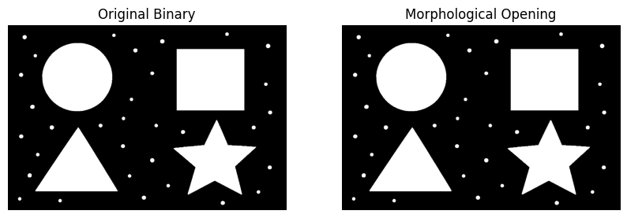

Ex22

import cv2
import matplotlib.pyplot as plt
from google.colab import files
import numpy as np
uploaded = files.upload()
filename = next(iter(uploaded))
img = cv2.imdecode(np.frombuffer(uploaded[filename], np.uint8), cv2.IMREAD_COLOR)
if img is None:
raise ValueError("Unable to read image.")
gray = cv2.cvtColor(img, cv2.COLOR_BGR2GRAY)
_, binary = cv2.threshold(gray, 127, 255, cv2.THRESH_BINARY)
kernel = cv2.getStructuringElement(cv2.MORPH_RECT, (5, 5))
result = cv2.morphologyEx(binary, cv2.MORPH_CLOSE, kernel)
plt.figure(figsize=(10, 4))
plt.subplot(1, 2, 1)
plt.imshow(binary, cmap="gray")
plt.title("Original Binary")
plt.axis("off")
plt.subplot(1, 2, 2)
plt.imshow(result, cmap="gray")
plt.title("Morphological Closing")
plt.axis("off")
plt.show()

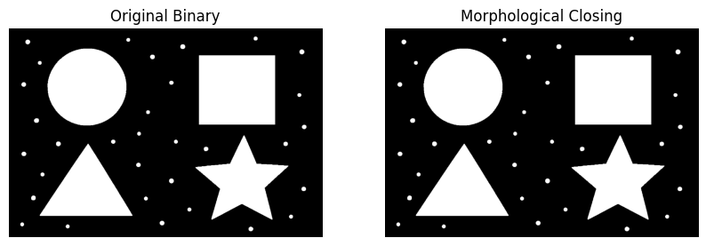

Ex23

import cv2
import matplotlib.pyplot as plt
from google.colab import files
import numpy as np
uploaded = files.upload()
filename = next(iter(uploaded))
img = cv2.imdecode(np.frombuffer(uploaded[filename], np.uint8), cv2.IMREAD_COLOR)

if img is None:
raise ValueError("Unable to read image.")
gray = cv2.cvtColor(img, cv2.COLOR_BGR2GRAY)
kernel = cv2.getStructuringElement(cv2.MORPH_RECT, (15, 15))
result = cv2.morphologyEx(gray, cv2.MORPH_TOPHAT, kernel)
plt.figure(figsize=(10, 4))
plt.subplot(1, 2, 1)
plt.imshow(gray, cmap="gray")
plt.title("Original Grayscale")
plt.axis("off")
plt.subplot(1, 2, 2)
plt.imshow(result, cmap="gray")
plt.title("Top-Hat Result")
plt.axis("off")
plt.show()

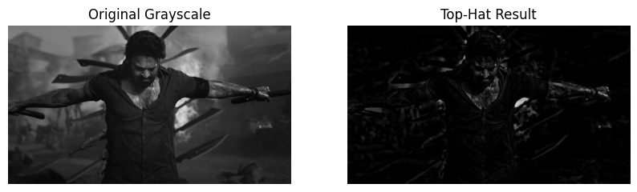

Ex24

import cv2
import matplotlib.pyplot as plt
from google.colab import files
import numpy as np

uploaded = files.upload()
filename = next(iter(uploaded))
img = cv2.imdecode(np.frombuffer(uploaded[filename], np.uint8), cv2.IMREAD_COLOR)

if img is None:
raise ValueError("Unable to read image.")

gray = cv2.cvtColor(img, cv2.COLOR_BGR2GRAY)
kernel = cv2.getStructuringElement(cv2.MORPH_RECT, (15, 15))
result = cv2.morphologyEx(gray, cv2.MORPH_BLACKHAT, kernel)

plt.figure(figsize=(10, 4))
plt.subplot(1, 2, 1)
plt.imshow(gray, cmap="gray")
plt.title("Original Grayscale")
plt.axis("off")
plt.subplot(1, 2, 2)
plt.imshow(result, cmap="gray")
plt.title("Black-Hat Result")
plt.axis("off")
plt.show()

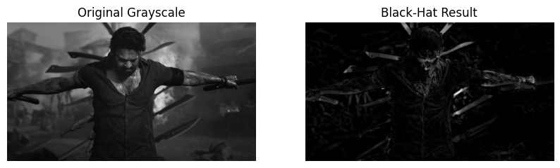

Ex25

import cv2
import matplotlib.pyplot as plt
from google.colab import files
import numpy as np
print("Upload the reference image of the watch:")
reference_upload = files.upload()
print("Now upload the image in which you want to find the watch:")
scene_upload = files.upload()
reference_name = next(iter(reference_upload))
scene_name = next(iter(scene_upload))
reference = cv2.imdecode(
np.frombuffer(reference_upload[reference_name], np.uint8),
cv2.IMREAD_COLOR
)
scene = cv2.imdecode(
np.frombuffer(scene_upload[scene_name], np.uint8),
cv2.IMREAD_COLOR
)
if reference is None or scene is None:
raise ValueError("Unable to read one or both images.")
gray_reference = cv2.cvtColor(reference, cv2.COLOR_BGR2GRAY)
gray_scene = cv2.cvtColor(scene, cv2.COLOR_BGR2GRAY)
# Detect and describe distinctive image features
sift = cv2.SIFT_create()
kp1, des1 = sift.detectAndCompute(gray_reference, None)
kp2, des2 = sift.detectAndCompute(gray_scene, None)
result = scene.copy()
found = False
if des1 is not None and des2 is not None and len(kp1) >= 4 and len(kp2) >= 4:
matcher = cv2.BFMatcher()
pairs = matcher.knnMatch(des1, des2, k=2)
good = [m for m, n in pairs if m.distance < 0.7 * n.distance]
if len(good) >= 6:
src_pts = np.float32(
[kp1[m.queryIdx].pt for m in good]
).reshape(-1, 1, 2)
dst_pts = np.float32(
[kp2[m.trainIdx].pt for m in good]
).reshape(-1, 1, 2)
matrix, mask = cv2.findHomography(
src_pts, dst_pts, cv2.RANSAC, 5.0
)
if matrix is not None and mask is not None:
h, w = gray_reference.shape
corners = np.float32([
[0, 0], [w - 1, 0],
[w - 1, h - 1], [0, h - 1]
]).reshape(-1, 1, 2)
projected = cv2.perspectiveTransform(corners, matrix)
inliers = int(mask.sum())
if inliers >= 6:
cv2.polylines(
result, [np.int32(projected)],
True, (0, 255, 0), 3
)
found = True
if found:
print("Possible watch match detected!")
else:
print("Watch not confidently detected. Try clearer images.")
plt.figure(figsize=(12, 5))
plt.subplot(1, 2, 1)
plt.imshow(cv2.cvtColor(reference, cv2.COLOR_BGR2RGB))
plt.title("Reference Watch")
plt.axis("off")
plt.subplot(1, 2, 2)
plt.imshow(cv2.cvtColor(result, cv2.COLOR_BGR2RGB))
plt.title("Watch Matching Result")
plt.axis("off")
plt.tight_layout()
plt.show()

